**How to configure and run the Application**

To run the application, you need to configure first the following before everything works.

1. Open the solution and select the project “**AgeRange.API**”
2. Right click on the project and click properties. See below:

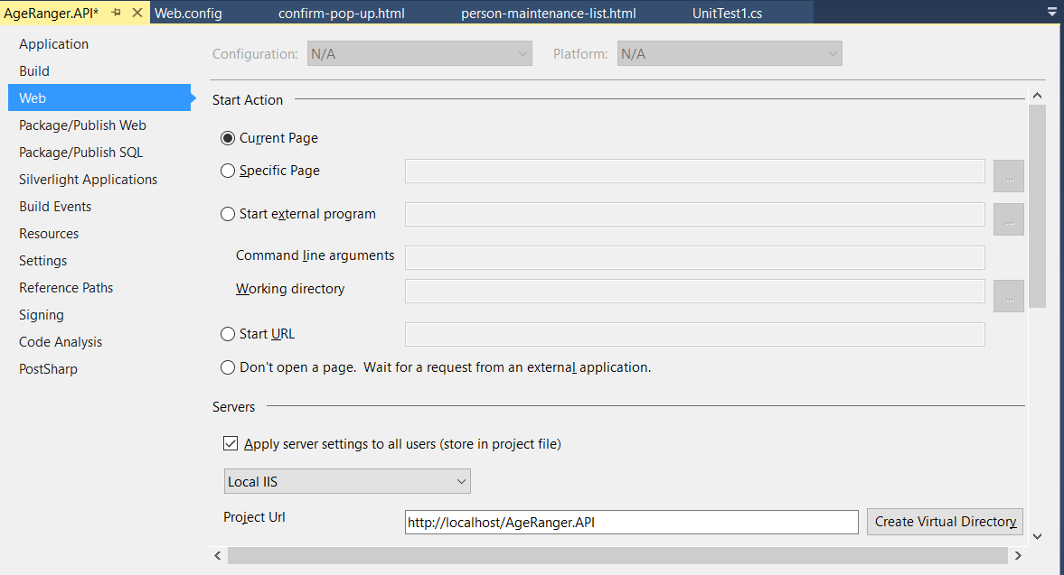

1. Go to **Web** tab and change the before the Project URL from **IIS Express** to **Local IIS** then click the button “Create Virtual Directory”. See below:

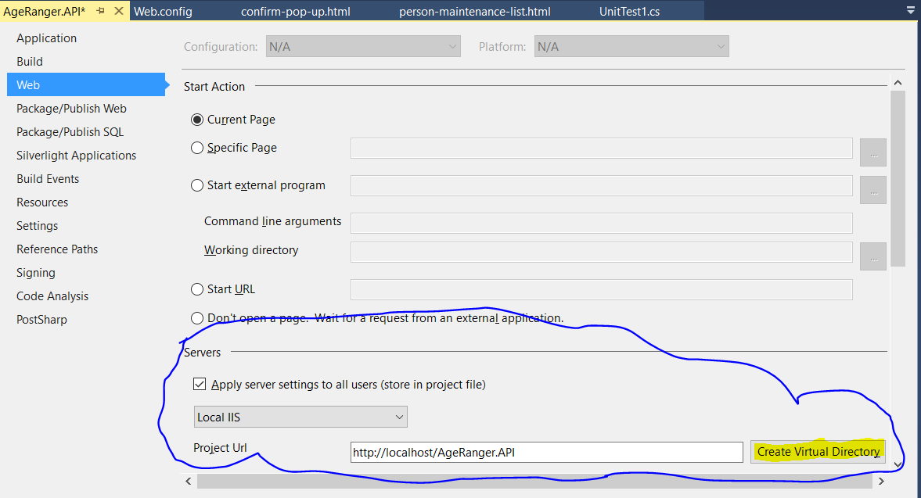

**Note:** To do this you need to have an **Administrator Access** and be sure that **Local IIS** was installed in your machine

1. After that, select the “**AgeRanger**” project then right click it and click “Open Folder in File Explorer” or you can do this manually using windows explorer and navigate to the directory of the “**AgeRanger**” project. See below:

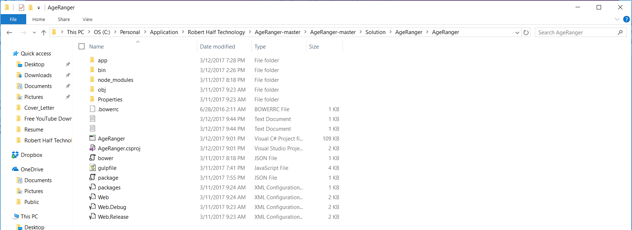

1. Right click to any place in the directory and if you have installed the “**GITShell**” select “**GIT Bash Here**”. See below:

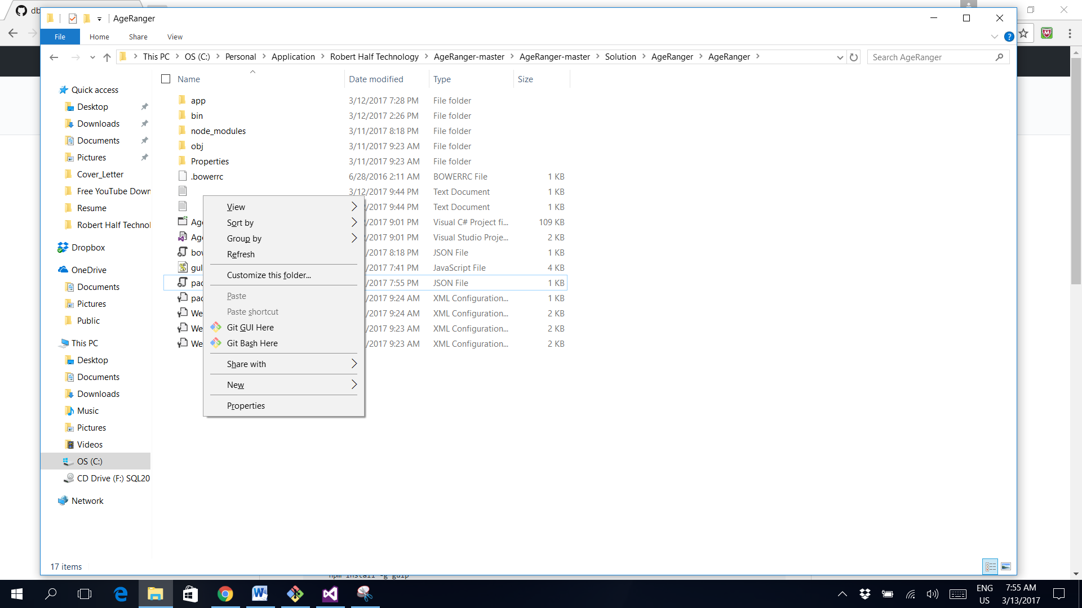

1. After right clicking the GIT shell will be display like the one below:

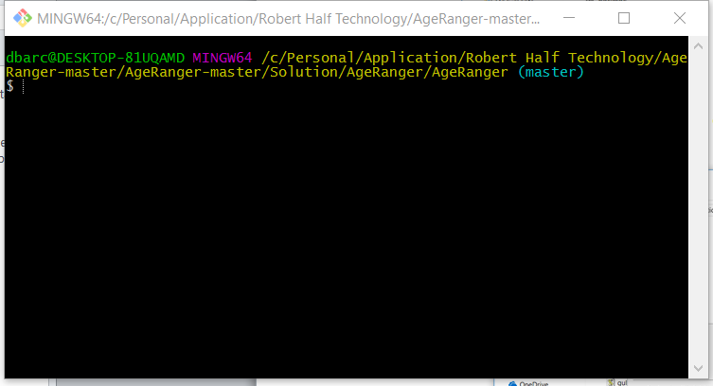

If you have not installed the GIT in your machine you can run the “cmd” to open the console and navigate to the directory of the “**AgeRanger**” project

1. Assuming you have all set-up the instruction and prerequisites in the “**readme.md”,** to run the web client just type in the console “**gulp serve**. See below:

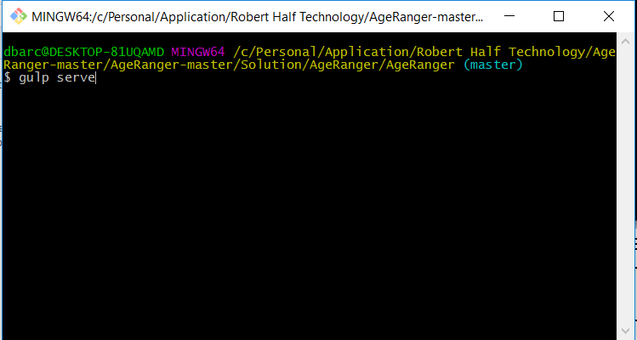

1. Upon pressing the “**Enter**”, the node.js server will be started. See below:

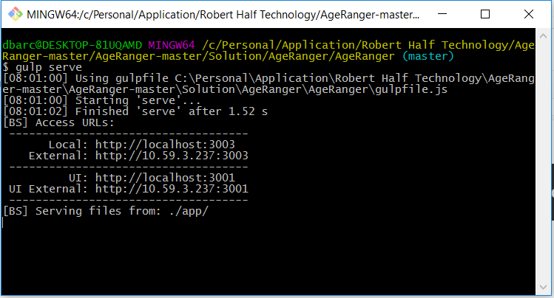

1. Then, an explorer will be open to show the web client interface. See below:

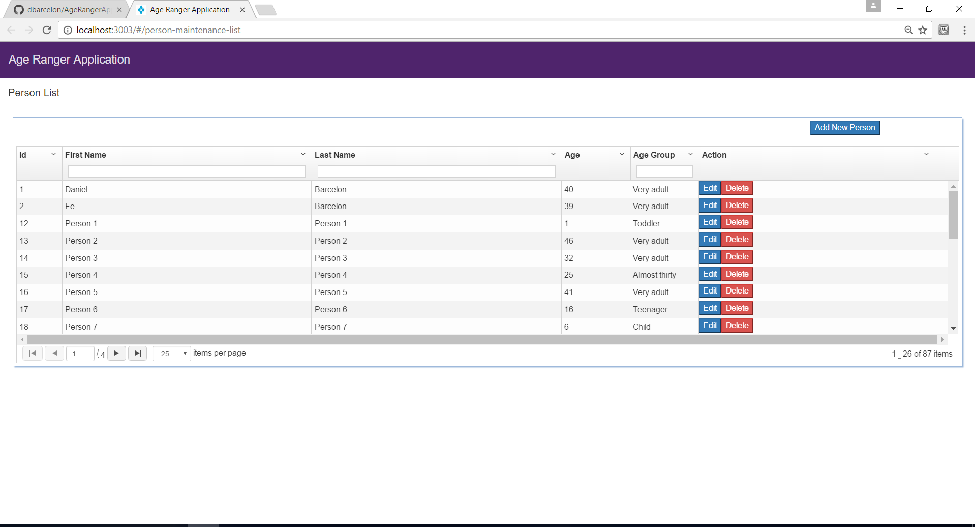

1. Whenever you have changes in HTML files or Javascript files and save it the web will be automatically refresh.